The column Severe_Crime is the result of feature engineering, In which,

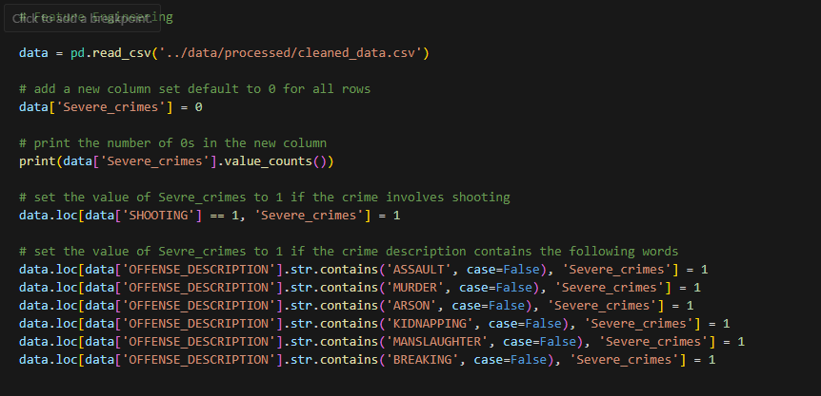

This creates a new column that only have categorical values of 1 and 0. And this indicates that if this crimes needs more law enforcement force and more equipment to handle.

For synthetic data, 1000 synthetic data was added for testing purpose.

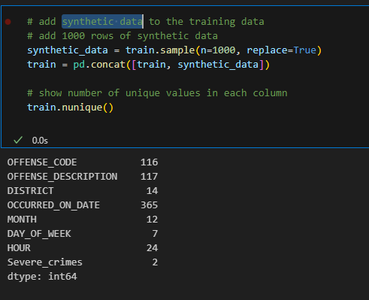

If adding more data will lead to a better result of the model accuracy, larger number of synthetic will be used. If this shows no help, the original dataset will be used for final model training.